**Medical Images**

* Measurement of human body at different scales
* Multidimensional – 2D, 3D, 4D, nD
* Large dynamic range
* Different image modalities
* Hug data size: example a high resolution MR image of brain -> 100 MB
* Normal images – 8 bits/pixel (1 byte), medical images – 12 bits/pixel (2 bytes)
* Software tools : ITK (Insight Toolkit), VTK (visualization Toolkit), SLICER, ImageJ
* **DICOM** stands for **D**igital **I**maging and **CO**mmunications in **M**edicine: it is an international standard related to the exchange, storage and communication of digital medical images and other related digital data.

**Medical Image Modalities**



1. X-rays imaging/radiography :
   * chest x-rays, fluoroscopy, mammography, motion tomography, angiography, age estimaton
   * For dense tissues like bone
2. Ultrasound Imaging (US) :
   * uses sound waves >20KHz,
   * based on assumption that sound velocity is uniform throughout body,
   * used in foetus examination, blood flow in vessels and stones in gall bladder
3. Computed Tomography (CT):
   * tomo means slice and graph means draw,
   * 3D views – Sagittal, Coronal, Axial
   * Standard imaging form many organs, lung imaging, bone imaging
   * Pixel Unit – Hounsfield unit (HU)
   * Radiation exposure



1. Magnetic Resonance Imaging (MRI)
   * MRI has excellent soft tissue contrast, while CT is preferred for lung and bone imaging.
   * No radiation exposure
   * Soft tissue refers to tissues that connect, support, or surround other structures and organs of the body. Soft tissue includes muscles, tendons, ligaments, fascia, nerves, fibrous tissues, fat, blood vessels, and synovial membranes.
   * CT is fast (few seconds), while MRI is slow (sparse MRI ~5-10 mins, abdomen or brain may take 30-40 mins)
   * Types based on contrast – T1, T2, PD, FLAIR

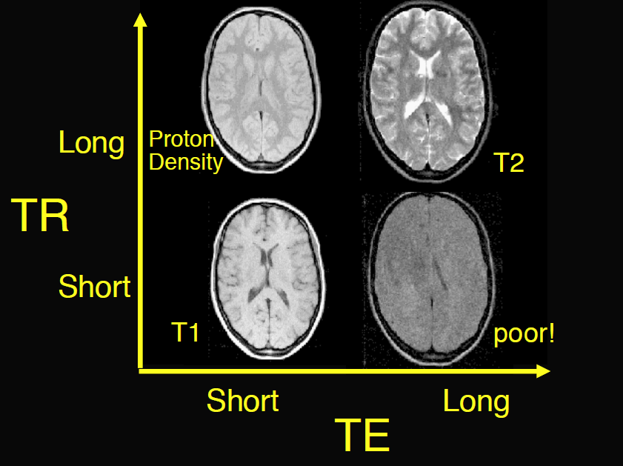

1. Diffusion Tensor Imaging (DTI)
2. Diffusion Weighted Imaging (DWI)
3. Functional MRI (Fmri)
   * Measures brain activity through oxygen concentration in blood flow
   * Based on fact that cerebral blood flow and neuronal activation are coupled
   * Ex: which part or location of brain is activated when reading?
4. Neural Medical Imaging – PET/SPECT
   * Also combined with MRI or CT to form hybrid image

**Pre-processing of Medical Images**

* Volume of interest (VOI), region of interest (ROI) and intensity of interest (IOI)
* Image filtering – to suppress unwanted (non-object) info and enhance wanted (object) info
  + Enhance methods : improve contrast and highlight objects/features
    - May produce artifacts and loss of some details
  + Suppressive methods : remove noise
* Histogram based analysis
* Types of resolutions-
  + Spatial – smallest structure that can be represented
  + Contrast – measure of perceptibility of structures
    - Measures local change in brightness i.e. how different are two neighboring structures look with similar but not equal appearances
* Image artifacts
  + Noise – MRI, PET, CT, DTI, DWI
  + Intensity non-homogeneity – MRI
  + Intensity non-standardness – MRI
  + Partial volume- MRI, PET
* Noise
  + 2 types –
    - signal independent noise: g = f+n; Gaussian
    - signal dependent noise: g = f*n; Poisson
    - Often, medical images are considered to have Gaussian noise, however PET/SPECT images have mixed Poisson/Gaussian, and MRI have Rician type noise.
    - Rician distribution : low-resolution image with targets in weak clutter (like SAR)[ <https://www.ncbi.nlm.nih.gov/pmc/articles/PMC3270869/>]
  + To suppress noise, image filtering is used
    - Box filtering (average smoothing)
    - Gaussian smoothing
    - Median filtering : removes noise without significant blurring
    - Unsharp masking : lower noise, higher contrast
      * Not only noise removal but edge enhancement also

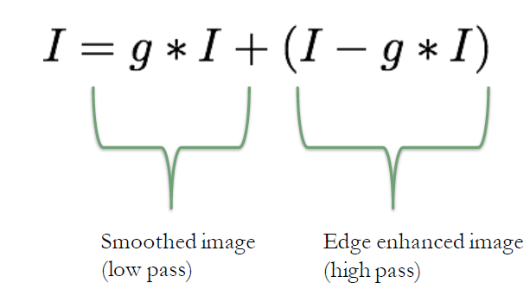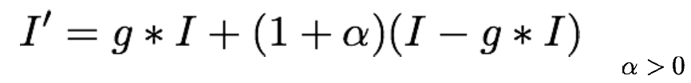

* + Edge detection: LOG~ difference of Gaussian
  + Image quality metrics for evaluation noise removal
    - SNR (signal-to-noise ratio)
    - CNR (contrast-to-noise ratio)
  + Diffusion based smoothing
    - Perona-malik filtering, aka, aniostroping diffusion filtering
    - APPROACH: Increase the diffusivity of filter for large (homogeneous) regions, and decrease it nearby edges

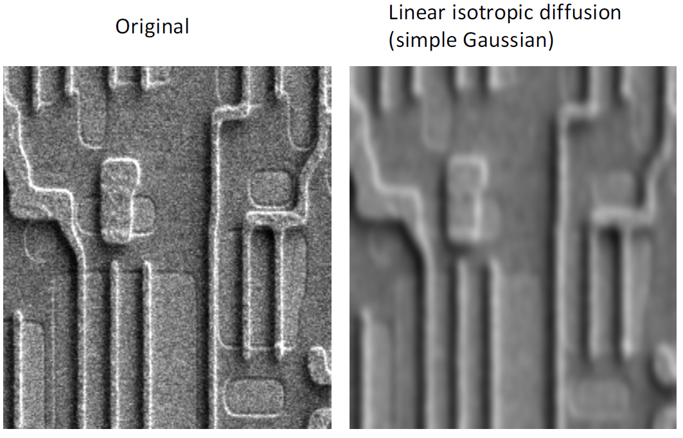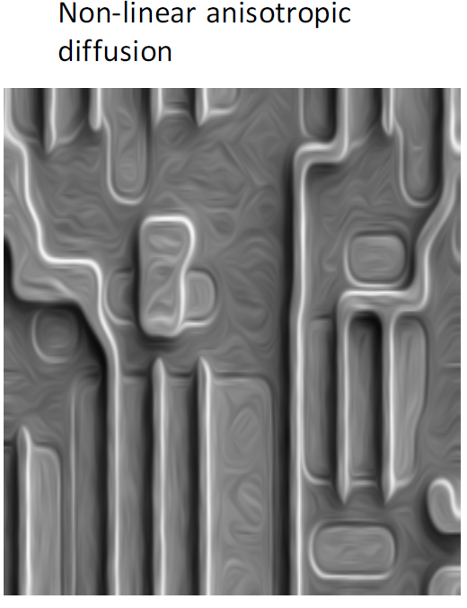

* Intensity non-homogeneity correction in MRI
  + Different tissues have different magnetic susceptibility => non-homogenous magnetic field => image distortion (background variations)

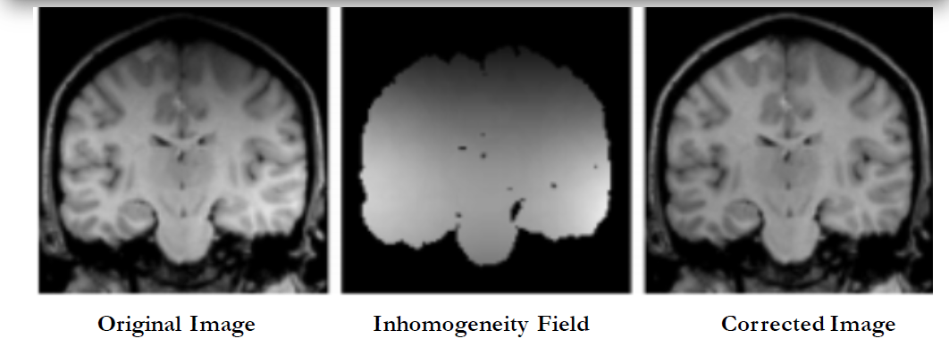



* + Distortions are most noticeable near air-tissue interfaces
  + Registration, segmentation and quantification processes are significantly affected
  + Correction methods [ read in detail later] -
    - Prospective approaches- phantom, multicoil, special sequence
    - Restrospective approaches- filtering, surface fitting, segmentation, histogram-based; 2 popular methods – N3 and SBC
  + This process is also called bias correction
  + Evaluation metric – CoV (Coefficient of variation)
* Intensity standardization in MRI
  + Acquisition-to-acquisition signal intensity variations is inherent in MRI
  + Intensity values have no tissue-specific semantic meaning
  + Poses problems for image display, segmentation, registration, localization and qualitative analysis

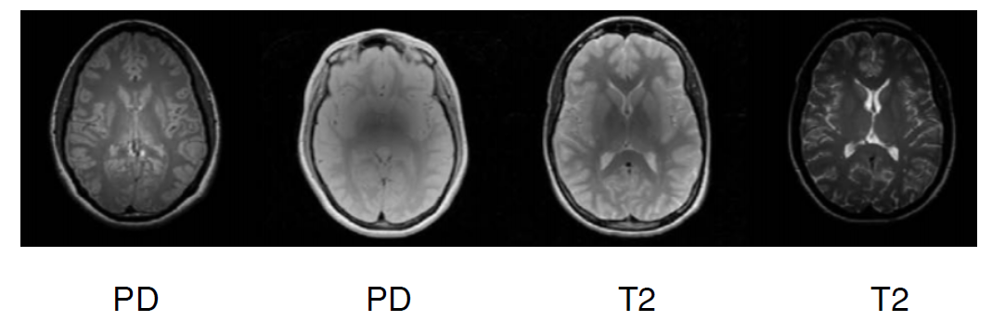

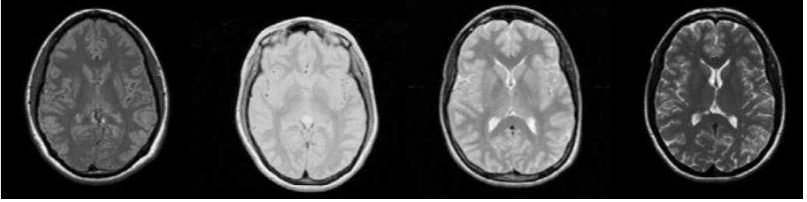

* + Simple linear scaling does not help
  + Histogram-based scaling is done – map background and foreground into the fixed intensity regions

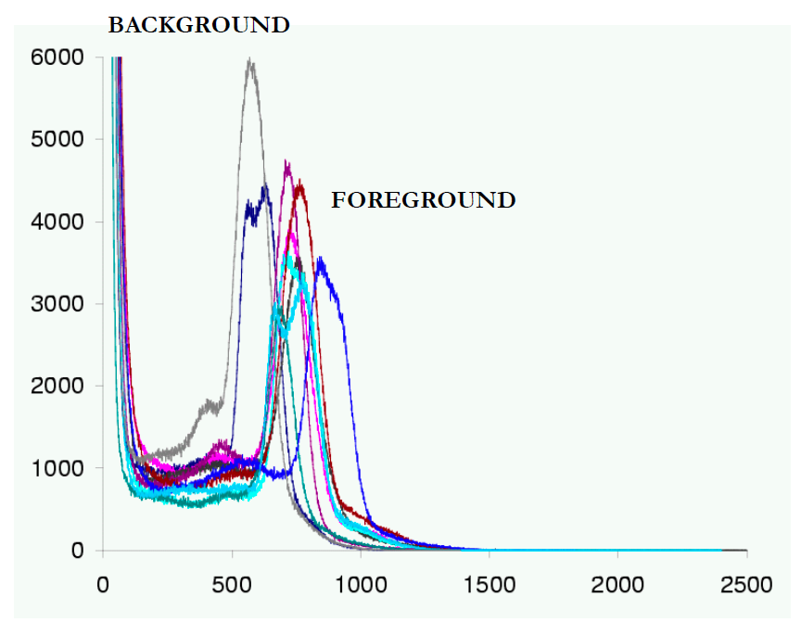 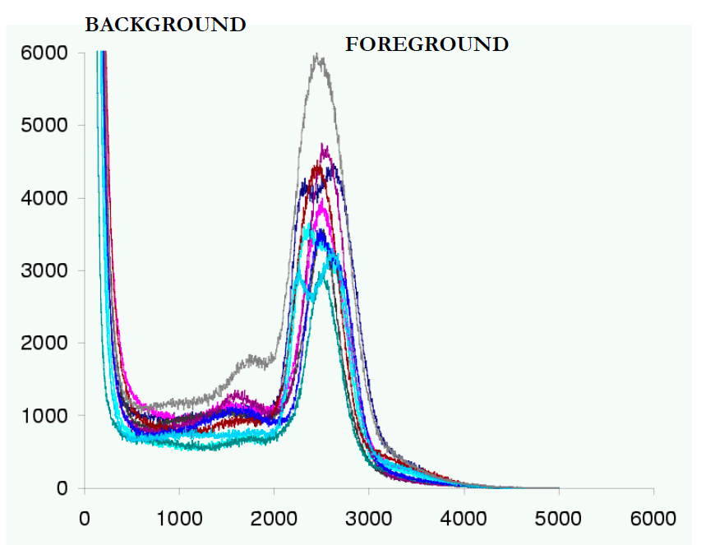

* + To determine standardized parameters, one way is to have some training iamges and find average values for histograms parameters
* Standard procedure to pre-process MRI

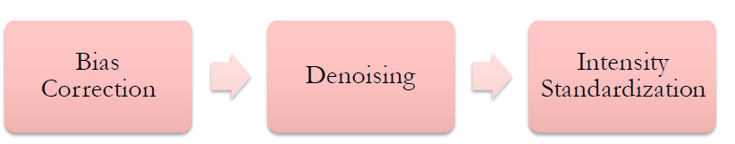

Summary - Overview of deep learning in medical imaging focusing on MRI

* Healthcare applications
  + 1D biosignal analysis
  + Prediction of medical events like seizures and cardiac arrests
  + CAD detection and diagonosis supporting clinical decision making and survival analysis
  + Drug discovery
  + Therapy selection and pharmacogenomics
  + Stratified care delivery
  + Analysis of Electronic health records
* Companies with healthcare division
  + Google brain <https://ai.google/healthcare>
  + Deepmind <https://deepmind.com/about/health>
  + Microsoft <https://www.microsoft.com/en-us/research/research-area/medical-health-genomics/>
  + IBM <https://www.research.ibm.com/healthcare-and-life-sciences/>
* Supervised learning is most commonly used in medical image analysis
  + Classifying skin-lesions according to malignancy
  + Discovering cardiovascular risk factors from retinal fundus photographs
* Deep learning, medical imaging and MRI
  + Some deep learning applications
    - Efficient improvement in radiology practices
    - Image registration to enable quantitiative analysis across difeerent physical imaging modalities and across time
    - Medical imaging – neuroimaging, breast cancer, chest imaging, brain segmentation, medical ultrasound
* Open-source tutorials
  + <https://github.com/paras42/Hello_World_Deep_Learning> - dl model to differentiate chest x-ray from abdominal x-ray
  + <https://medium.com/tensorflow/an-introduction-to-biomedical-image-analysis-with-tensorflow-and-dltk-2c25304e7c13> - DLTK tutorial
  + <https://github.com/usuyama/pydata-medical-image> -Diabetic Retinopathy classification and Lung Nodule Detection based on CNTK
* Deep learning in MRI
  + Two parts
    - Low-level operations: signal processing chain close to physics of MRI such as reconstruction, restoration and registration
    - High-level operations: image segmentation, classification, disease detection, disease prediction, CBIR, combining images and text reports

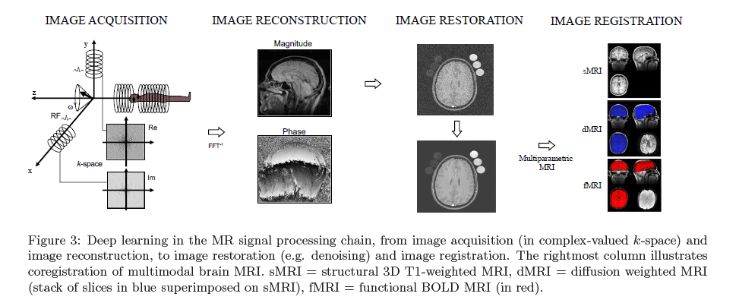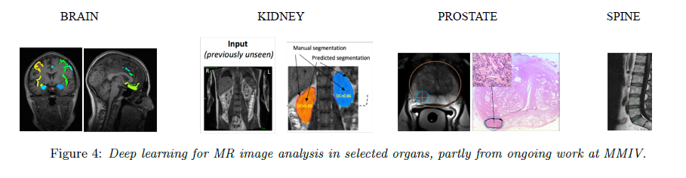

* Low-level operations: From image acquisition to image registration
  + Data acquisition and image reconstruction
    - Methods: convRNN, deep cascaded CNN+ augmentation, least-squares GAN, AUTOMAP
  + Quantitative parameters- QSM amd MR fingerprinting
    - Quantitative susceptibility mapping (QSM) is a growing field of research in MRI, aiming to noninvasively estimate the magnetic susceptibility of biological tissue
      * Methods: COSMOS[baseline], QSMNet, DeepQSM
    - Magnetic resonance fingerprinting (MRF) is a promising new approach to obtain standardized imaging biomarkers from MRI
      * In medicine, a biomarker is a measurable indicator of the severity or presence of some disease state. More generally a biomarker is anything that can be used as an indicator of a particular disease state or some other physiological state of an organism
  + Image restoration (denoising and artifact detection)
    - Methods for denoising: AE with skip connections, ensembles of DNN, direct estimation of denoised parameters from sensor data (k,t) space, i.e., no reconstruction step
    - MR artifact detection
      * Poor-quality spectra
      * Ghosting artifacts
      * Patient motion artifacts
  + Image superresolution
    - constructing higher-resolution image from obtained lower-resolution image
    - used to improve the trade-off between resolution, SNR and acquisition time
    - method : deepResolve
  + Image synthesis
    - An intensity transformation applied to a given set of input images to generate new image with a specific tissue contrast
    - GAN’s for biomedical image synthesis and text-to-image synthesis
  + Image registration
    - Very popular recently since large number of complementary and multi-parametric tissue information is being collected at very spatial resolution and for diverse set of patients
    - Challenging mix of geometry (spatial transformations), analysis (similarity measures), optimization strategies and numerical schemes
* High-level operations: from image segmentation to diagnosis and prediction
  + Image segmentation: holy grail of quantitiative image analysis
  + Diagnosis and prediction
  + Content based image retrieval
    - To provide medical cases similar to a given image in order to assist radiologists in the decision making process
  + Automated generation of radiology reports using LSTM for auto-generated
* Open science and reproducible research: select a problem you find interesting based on openly available data, a method described in a pre-print and an implementation uploaded on GitHub
* Challenges
  + Medical images are 3D which requires more memory and computation resources
    - Methods to deal with this are treating 3D’s as stacks of 2D’s, patch- or segment-based training and inference, downscaling
  + Data : access, privacy and protection
    - For privacy : federated learning, split learning and differential learning
    - Data shortage
      * Large difference between the high-quality images used in research and the messiness of real, clinical world
      * Transfer learning: first you train a network to perform a task where there is an abundance of data, and then you copy weights from this network to a network designed for the task at hand
      * Inter-organ transfer learning : brain -> kidney
      * Data synthesis: GAN, AE
      * Constructing more data-efficient DNN
        + Capsule networks- learn more domain specific elements through viewpoint invariance
        + Attention mechanism- enabling network to focus on the most informative components of each layer input
  + Interpretability
    - How can we trust prediction based on features we cannot understand?
    - New program by DARPA dedicated to this issue- Explainable AI
    - Bayesian deep learning: to estimate uncertainty measure
    - Producing valuable measures for uncertainty will also reduce DNN susceptibility to adversarial attacks
  + Workflow integration and regulations
  + Future directions
    - Will become easier to divide the problems into 3 categories: (i) best approached using deep learning techniques end-to-end, (ii) best tackled by a combination of deep learning with other techniques, or (iii) no deep learning component at all.
    - Computational medicine
    - Biosensors and edge-computing for lifestyle monitoring
    - New medical paradigm: predictive, preventive, personalized and participatory – P4 medicine.

Brain tumor segmentation

* detecting different types and grades of tumor in human brain
* in US, 23000 new cases of brain tumor were diagnosed in 2015
* in India, 1157294 new cases of all types of cancer in 2018

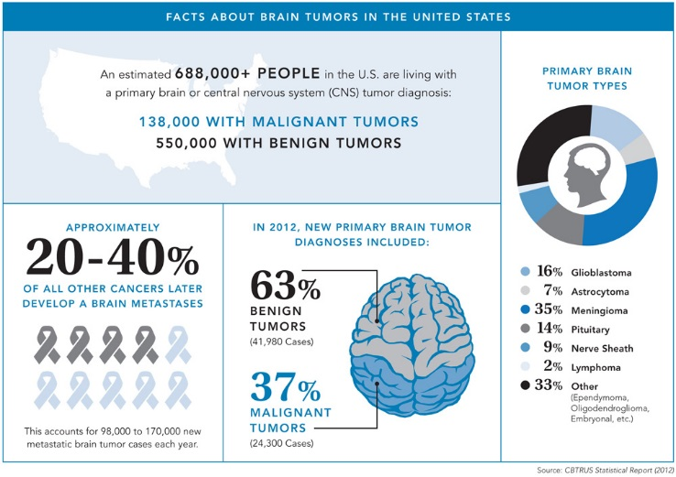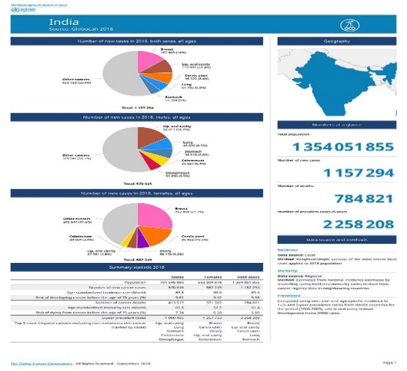

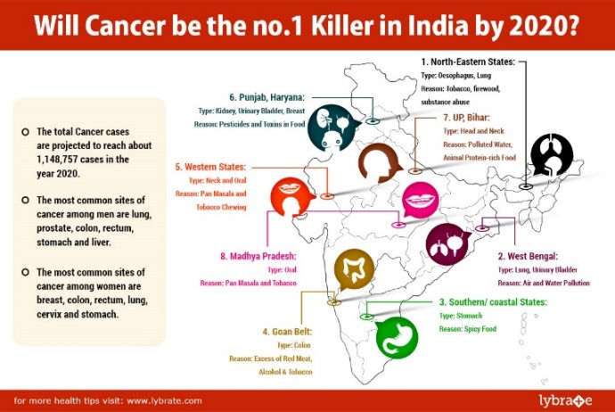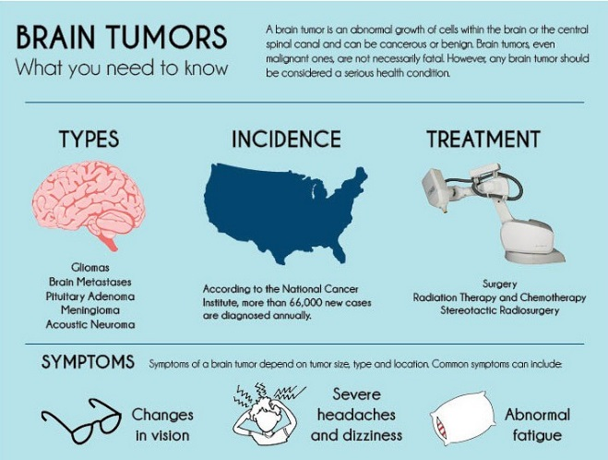

<https://gco.iarc.fr/> (explore this for numbers)

<http://cancerindia.org.in/cancer-statistics/>

<https://www.impactguru.com/blog/brain-tumor-in-children-in-india>

<https://www.thehindu.com/sci-tech/health/Over-2500-Indian-kids-suffer-from-brain-tumour-every-year/article14418512.ece>

<https://www.braintumourresearch.org/>

<https://www.thebetterindia.com/74188/cancer-awareness-india/>

* **40,000-50,000 new brain tumor cases** are reported in India, of which 20% are cases of brain tumor in children. This amounts to over **2,500 children each year.**  if these cases were to be detected early and correctly,**90% of the children would be cured**
* Common methods to treat – surgery, chemotherapy, radiotherapy : late detection
* a brain tumor is a mass or lump like **abnormal growth in the brain that can either be malignant or benign.** A malignant tumor is one that grows fast, is cancerous, and can spread at a rapid pace. Example: gliobastoma. Malignant brain tumors are what we also know as brain cancer.
* A benign tumor on the other hand is one that is **non-cancerous.** Example Meninggioma
* Brain tumors are categorized into two based on origin/location:
  + Primary tumors: ones that form and originate from the brain cells itself [70%]
  + Secondary tumors: ones that may have started somewhere else, but eventually spread to the brain [30%]

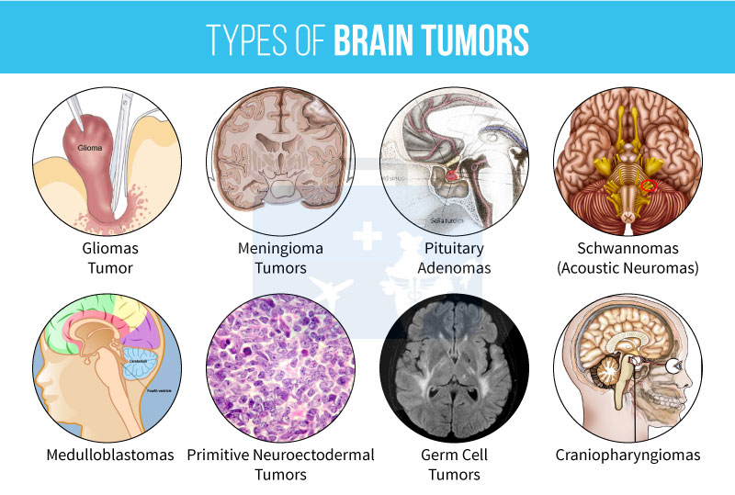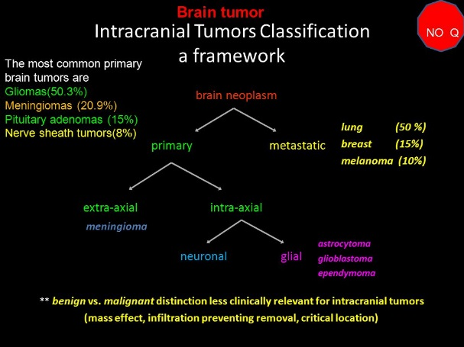

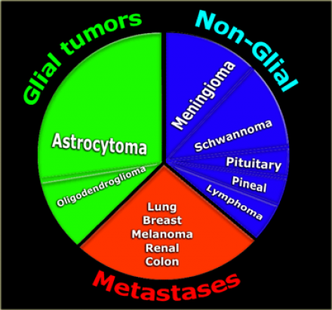

* About brain tumors
  + Gliomas are the most prevalent type of brain tumors that originate in the glial cells of the brain. Gliomas include 30% of all brain tumors and CNS, and 80% of all malignant brain tumors [7].
  + Gliomas classified into four grades according to the WHO starting from type I to IV [8]. Grade I tumors are benign and have a much similar texture of the normal glial cells, Grade II is a slightly different in texture, Grade III tumors are malignant with abnormal tissue appearance while grade IV is the most severe stage of gliomas and tissue abnormalities that can be visualized by naked eye [1].
  + Meningioma is a tumor that forms on the membrane that covers the brain and spinal cord inside the human skull and grows placidly. Most of meningioma tumors are benign [8].
  + Pituitary tumor starts from the pituitary glands that control hormones and regulate functions in the body. It can be benign, benign that expands to bones, and malignant. Complications of pituitary tumors may cause permanent hormone deficiency and vision loss [1].
* meningiomas are benign and easy to detect, but gliomas and gliobastomas are malignant and much more difficult to localize due to diffused, poorly contrasted and extend tentacle-like structures which make them difficult to segment

# Image result for gliomas and meningiomas Illustrations of three typical brain tumors: (a) meningioma; (b) glioma; and (c) pituitary tumor. Red lines indicate the tumor border. Â

# Illustrations of three typical brain tumors(a) meningioma; (b) glioma; and (c) pituitary tumor. Red lines indicate the tumor border

# 

* Different grades of gliomas tumor-
  + LGG (lower grade glioma/ astrocycotomas or oligodendrogliomas) – Less aggressive in a patient with a life expectancy of several years
  + HGG (higher grade glioma/glioblastoma)– more aggressive in a patent with a life expectancy of atmost 2 years
* Challenges
  + Can appear anywhere in brain
  + Almost any kind of shape, size or contrast, prohibiting the use of strong priors like shape and location as used for most anatomical structures
  + Tumor mass effect change the arrangement of the surrounding normal tissue, so limits the reliability of spatial prior knowledge for the healthy part of brain
  + MRI artifacts – intensity non-homogenity and non-standardized scale
  + Manual segmentation by experts show significant variations
  + Imbalanced data (healthy pixel comprise 98% of total voxels)
  + Images are huge size
* Why MRI for brain tumor segmentation?
  + Superior soft tissue resolution
  + No ionizing radiation
  + Possible to obtain different images providing complementary information, thus providing detailed information of brain – T1, T1 contrasted, T2, PD, diffusionMRI, fluid attenuation inversion recovery Flair, contrast between these modalities gives almost a unique signature to each tissue type
    - T2 and FLAIR MRI (highlighting differences in tissue water relaxational properties), post-Gadolinium T1 MRI (showing pathological intratumoral take-up of contrast agents), perfusion and diffusion MRI (local water diffusion and blood flow), and MRSI (relative concentrations of selected metabolites), among others
    - FLAIR – complete tumor, T2- Core tumor, T1-c – enhancing tumor structures

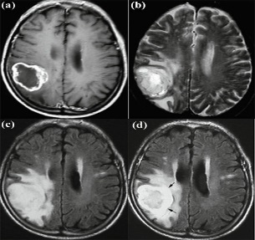 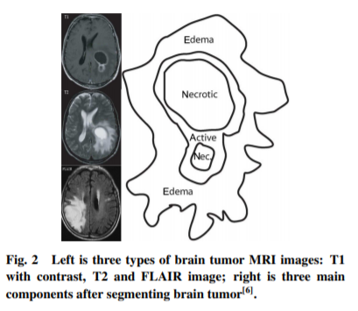



* + Great help to improve diagnostics, growth rate prediction and treatment planning
* Dataset- BraTS
  + In order to gauge the current state-of-the-art in automated brain tumor segmentation and compare between different methods, we organized in 2012 and 2013 a Multimodal Brain Tumor Image Segmentation Benchmark (BRATS) challenge in conjunction with the international conference on Medical Image Computing and Computer Assisted Interventions (MICCAI)
* Types of gliomas intra-tumoral classes
  + Edema (yellow) – sweeling near tumor
  + Non-enhancing solid core (red)
  + Enhancing core (blue)
  + 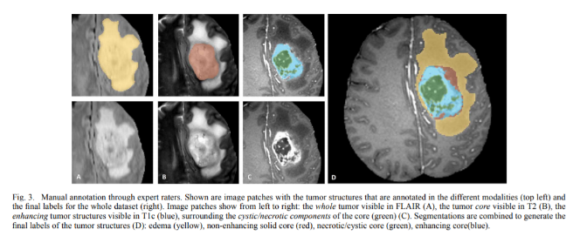Necrotic core (green) –cyst
  + 3 levels: complete(all), core (necrosis, non-enhancing+enhancing), enhancing
* Methods for brain tumor segmentation
  + Generative – use prior knowledge of brain anatomy such as shape (anatomical models)
    - Finding tumor brain images by matching it with a template of healthy brain images
  + Discriminative – use little prior knowledge and rely mostly on features and corresponding label of the voxel
    - Classical machine learning; Random forest most popular – learn very generic low-level features
      * too many features needed -> high computation load
      * less features by dimensionality reduction or feature selection -> loss of information
    - Deep learning – learn task-specific high-level features
      * Shallow CNN [ref]
      * 3D filters [ref]
      * 2 pathway where each pathway use different patch size to vary contextual information [ref]
      * Cascade of two network for 2 stage training to deal with class imbalance [ref]
      * First binary (tumor/no tumor) then multi(sub-regions of tumor) [ref]
      * Binary sub-tasks+dictionary [ref]
      * Very deep convolutional with 3x3 kernels, intensity normalization, data augmentation [ref]
* My solution – DNN based. 5 steps-
  + Pre-processing – noise filtering, bias correction, standardization
  + Patch-extraction
  + Training CNN
  + Post-processing – predefined threshold, connected component
  + Testing
* Some tricks
  + Dealing with large size image
  + Data imbalancing
* Dataset and Metric
  + BraTS 2013 dataset
    - comprised of 3 sub-datasets.
    - The training dataset, which contains 30 patient subjects all with pixel accurateground truth (20 high grade and 10 low grade tumors);
    - the test dataset which contains 10 (all high grade tumors) and
    - the leaderboard dataset which contains 25 patient subjects (21 high grade and 4 low grade tumors).
    - There is no ground truth provided for the test and leaderboard datasets.
    - All brains in the dataset have the same orientation.
    - For each brain there exists 4 modalities, namely T1, T1C, T2 and Flair which are coregistered.
    - The training brains come with groundtruth for which 5 segmentation labels are provided, namely non-tumor, necrosis, edema, non-enhancing tumor and enhancing tumor.

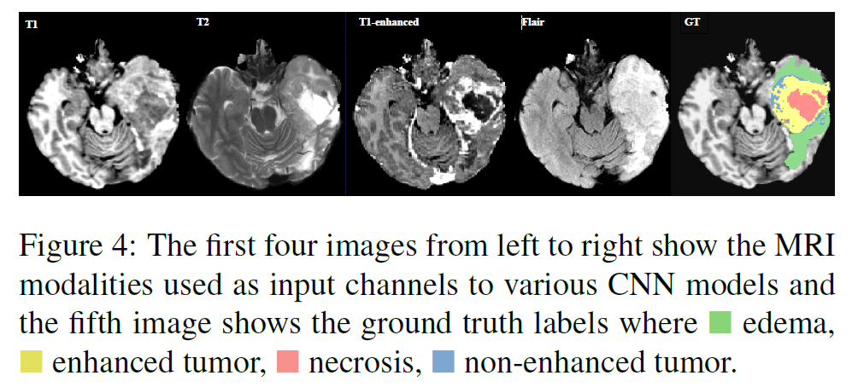

* Metrics
  + Dice score (like f-measure), specificity and sensitivity

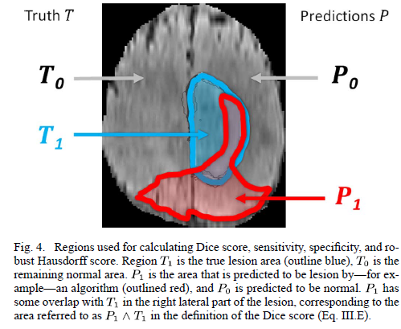

* Future Research direction –
  + not just tumor/no tumor or tumor types, but tumor grading

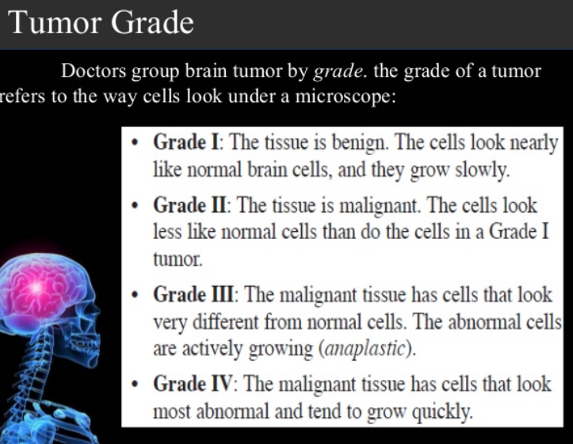

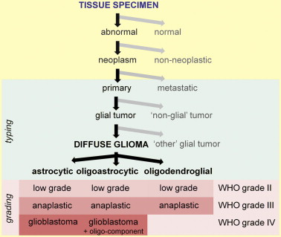

* + 3D networks for handling 3D voxels

<https://github.com/QTIM-Lab/DeepNeuro>